Attachment No 2

THE OFFER FORM

The Ordering Party:
Polish Tourism Organisation Office in Stockholm

THE CONTRACTOR:
....................................................................................................................................
VAT number ....................................... Org. Number ....................................................................
Correspondence Address:
....................................................................................................................................
Person to contact for the Ordering Party:
....................................................................................................................................
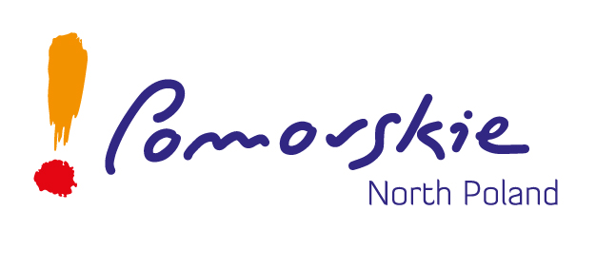

Phone number: ........................................................................................................
Fax number: .............................................................................................................
e-mail .........................................................................................................................
Answering to the Call we present following offer for:
Biking tours in Poland - online and printed media campaign in Sweden, Norway and Denmark between August 2019 and April 2020, including the production of the promotional material for the price of:

……………………………………………………………………………. EURO including VAT
(In words: ……………………………..……………………………………………………….)
The detailed offer, including the chosen media for the campaign, with their reach is attached.
The planned reach is: ................................ pax.

I confirm, that I have read the Call conditions and I do not object any of them as well as that I have received all the information and explanations necessary to prepare the offer.
I confirm the offer binding time of 30 days, starting with the deadline of offer submission.
I confirm, that in case the offer is chosen, it will be performed in the given price and term.
I confirm also that:
- The company is entitled to take part in such calls;
- The company possesses required knowledge and experience, followed by technical abilities;
- The company has financial and economical resources to conduct the order properly and in the good timing.

……………………………………
The signature of the person
entitled to represent the Contractor

